A

Report

On

WALL MAGAZINE 2025

Department of PHILOSOPHY

Rabindra Mahavidyalaya,

Champadanga, Hooghly

Session: 2024-25

Theme: Bibek Bodher Jagorore Swami VIbekananda

Venue: Rabindra Mahavidyalaya,

champadanga,

room no. 71

Date: 7th January,2025

Organizer: Department of Philosophy

Objectives:

- To enable the students to express their inner feelings.
- It also helps them in developing the positive and desirable qualities.
- The main objective of mobilizing wall magazine is to initiate writing tendency in pupil teacher and attract their attention on current incidents
- Development of soft skills.
- Ability to grow presentation skills, engage in meaningful discussion to arrive at a shared understanding their oral work, combining information.
- Enhancing students’ intelligence.
- Building students’ confidence
- Dealing with critical and argumentative situations

Notice

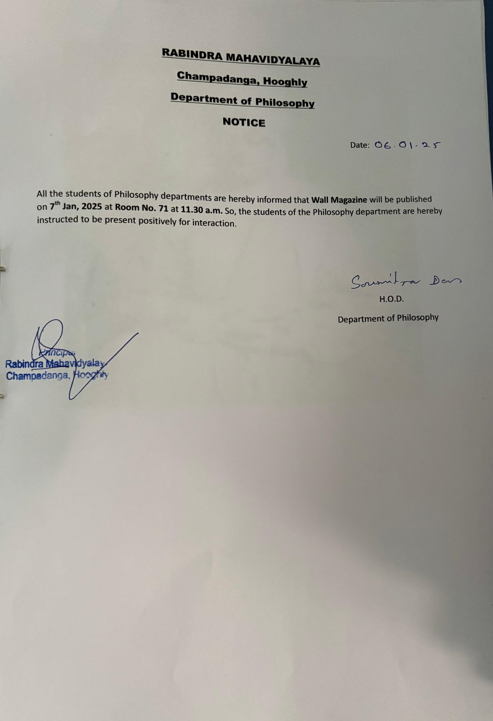

summary

Wall Magazine Report
A Wall Magazine is organized by the Department of Philosophy on 7th January 2025.Two more programs were held on that day, freshers welcome and Farewell. The topic of Wall Magazine was "Bibek Bodher Jagorore Swami VIbekananda". First prof. Sukla Saha, Professor of Philosophy Department, inaugurated the wall magazine on that day in the presence of professors and students. Students’ and professors from other departments were also present. The topic of wall magazine was presented in front of everyone by students and teaching faculty of philosophy department. The topic of wall magazine was presented in front of everyone by Bachhu Mahato (student) and prof. Sourish Dey of philosophy department. Teachers of other departments also gave speeches. Then everyone reaches room no 71 for the rest of the program. Along with some cultural events, such as recitals, dances, songs, speeches etc. are also held.
Wall magazine is an important means to enable the students to express their inner feelings. It also helps them in developing the positive and desirable qualities. The main objective of mobilizing wall magazine is to initiate writing tendency in pupil teacher and attract their attention on current incidents.

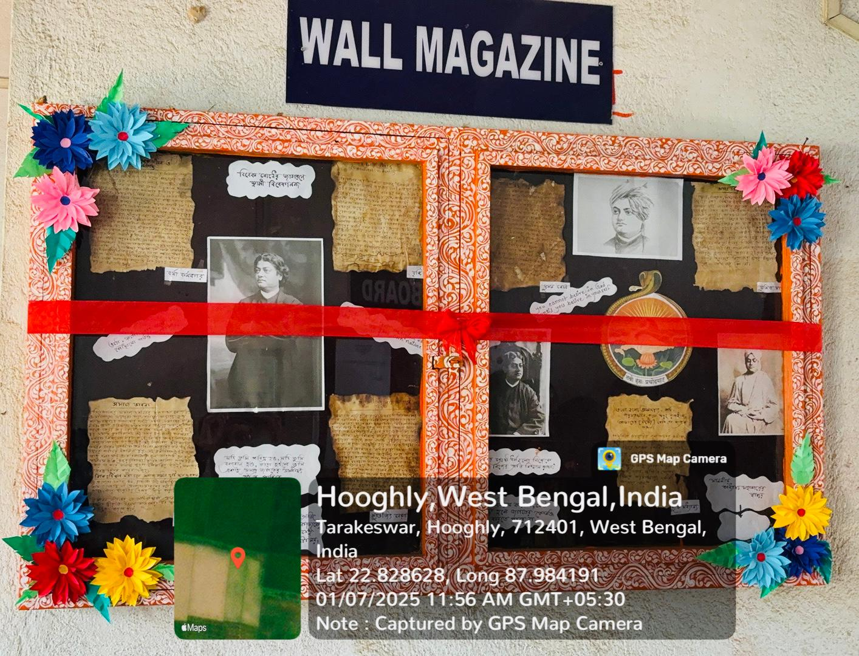
Theme: Bibek Bodher Jagorore Swami VIbekananda
Wall magazine decoration
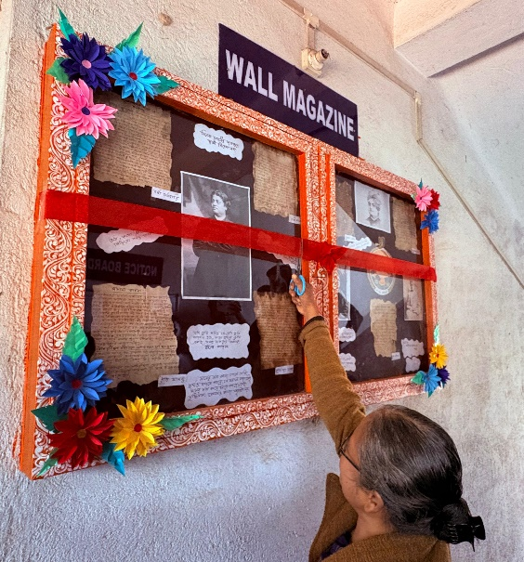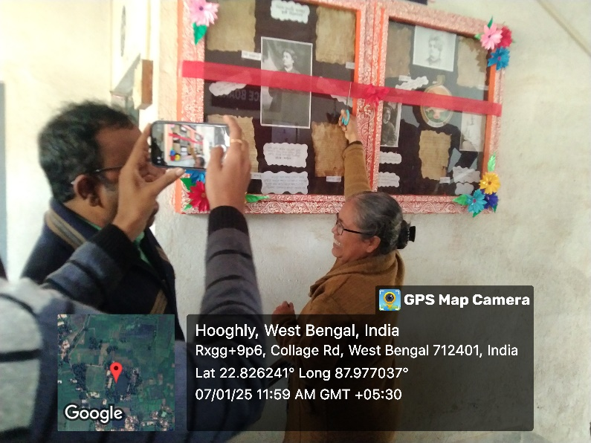

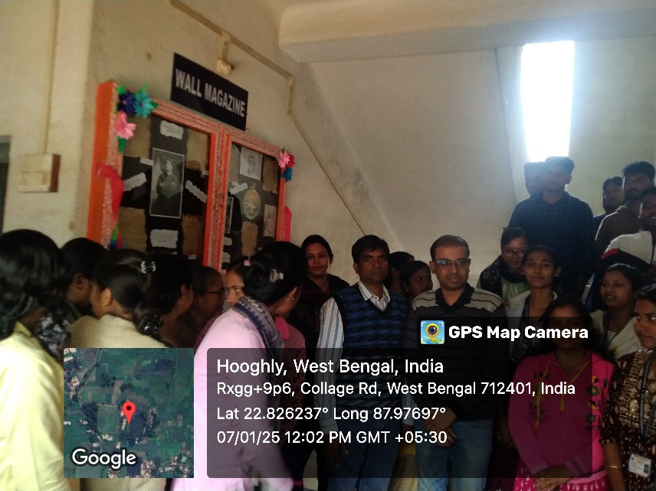
topic present by student
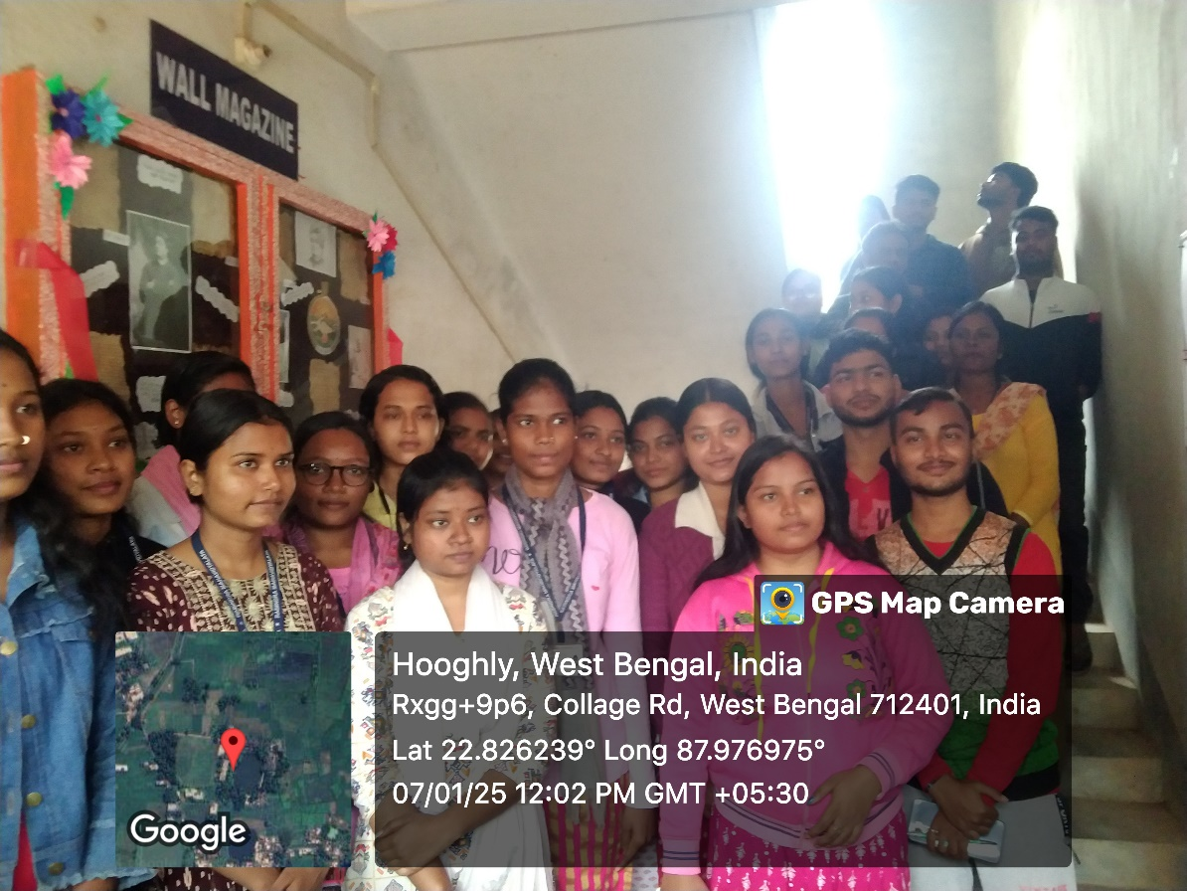
our students’

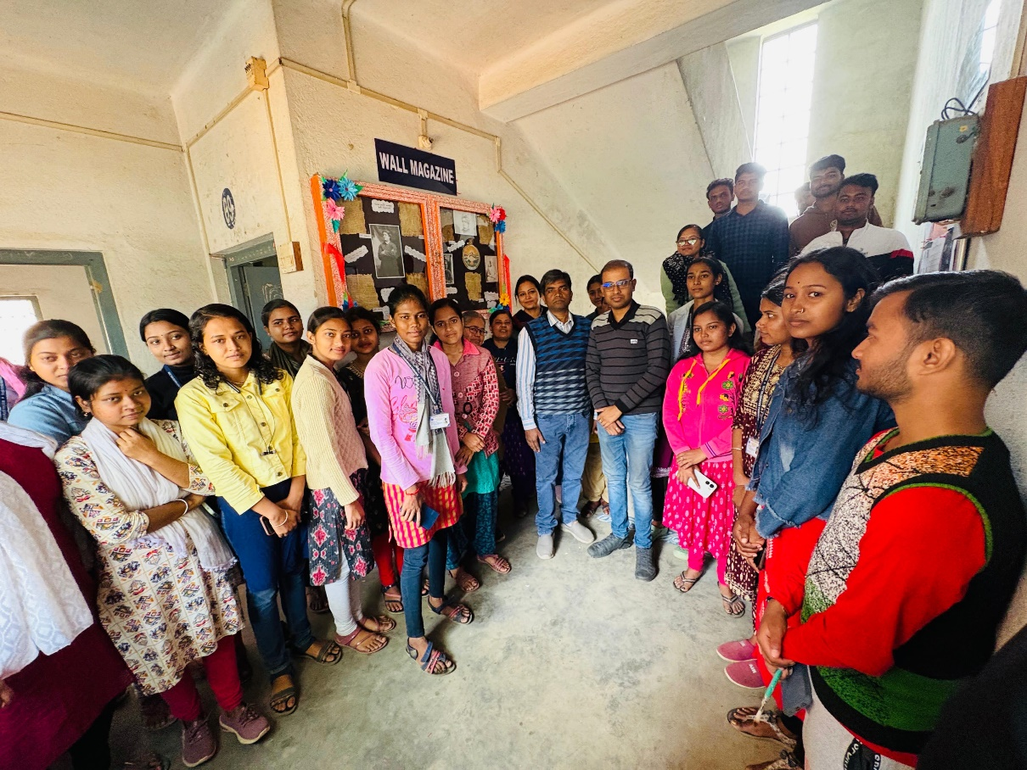
our students’
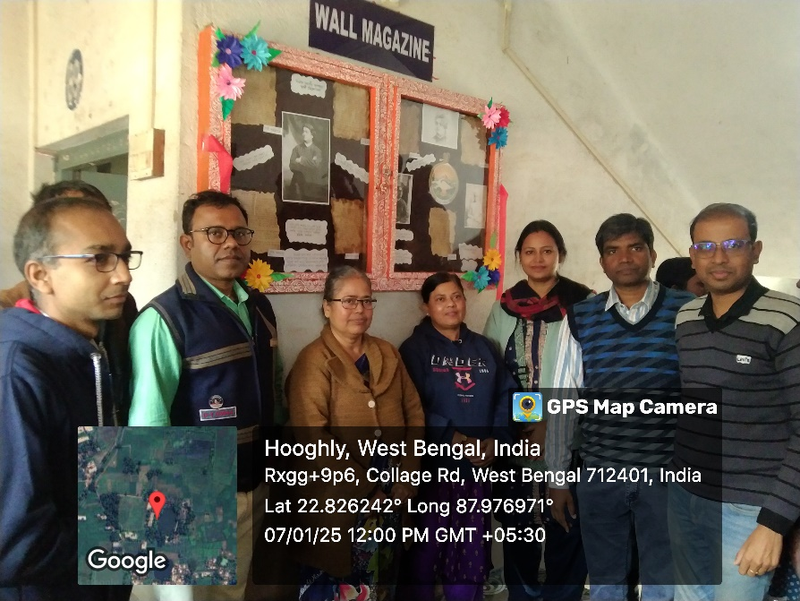
Another Departmental professor’s

Attendance sheet
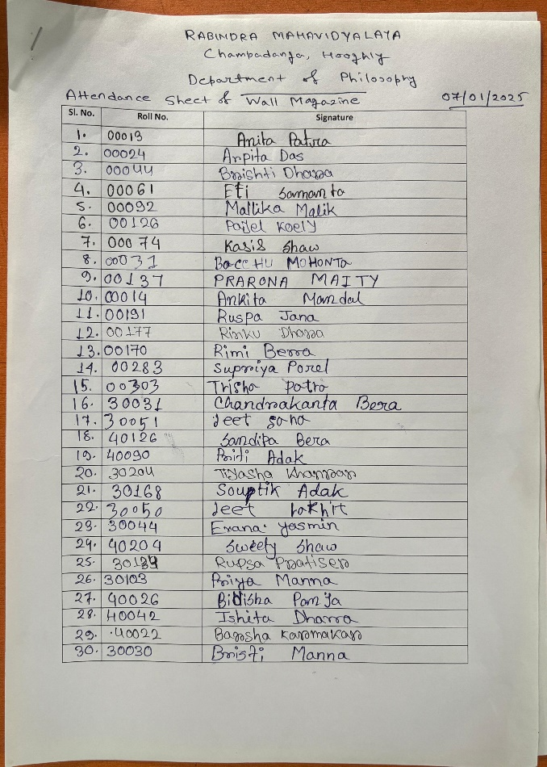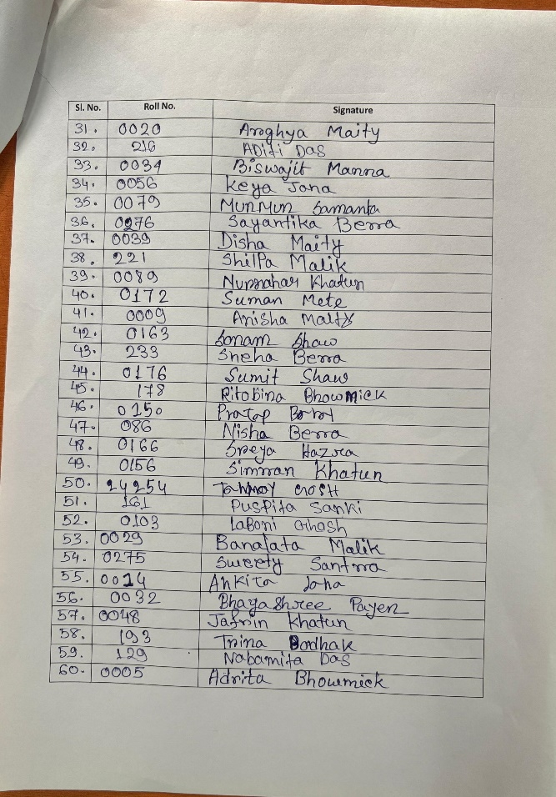

Our participant: 60
Male:15
Female:45

Tentative programmed schedule
- Inaugural session: 12 noon to 12.30 p.m.
- Theme present to audience: 12:30 p.m. to 1.00 p.m.

